Home page with server running

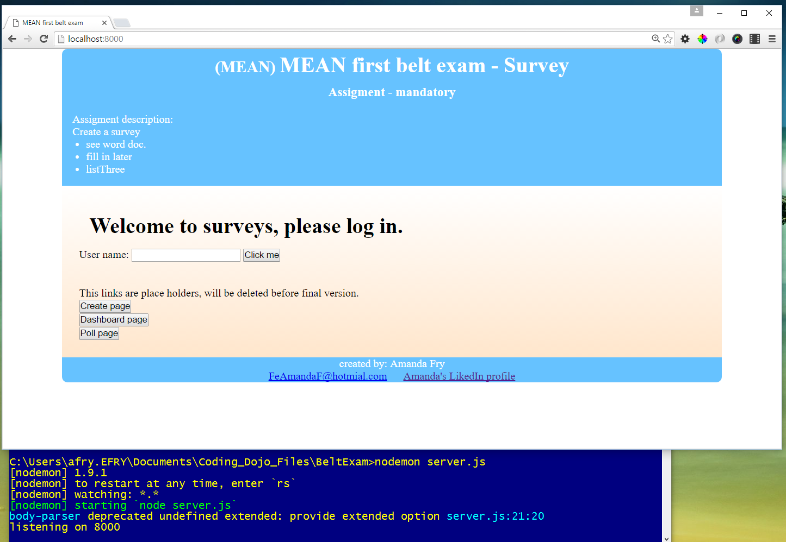

Click on the dashboard

* In the background I printed what records I should get.
* I was able to put the questions into a link that will take you to /poll but I will need to capture the id and pass it … on Friday
* Also I will need to work on the display better to cut off the time zone for sure maybe even seconds

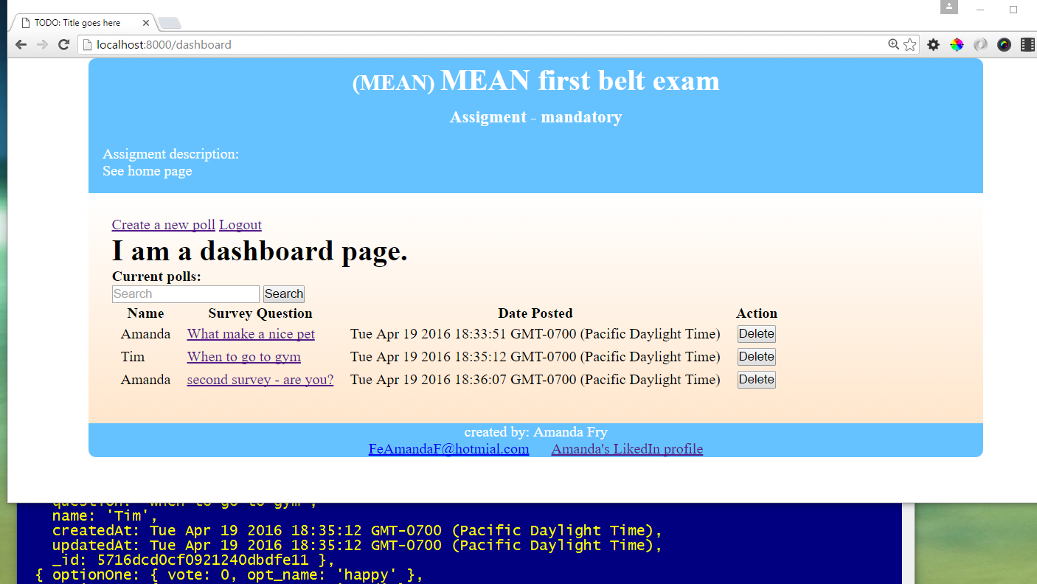

Clicked on one of the link:

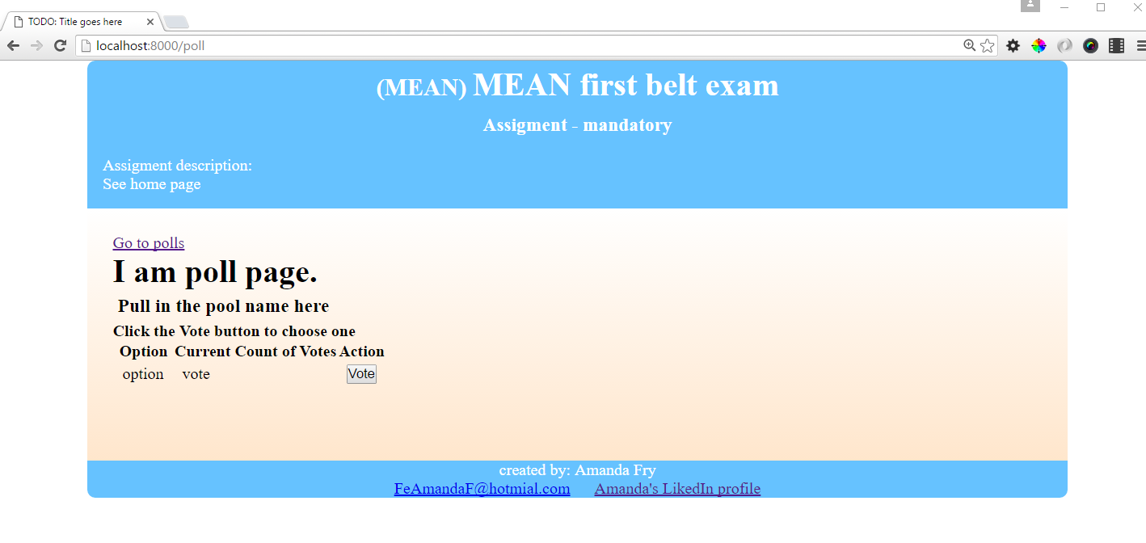

Went back to home page and clicked on the create poll records: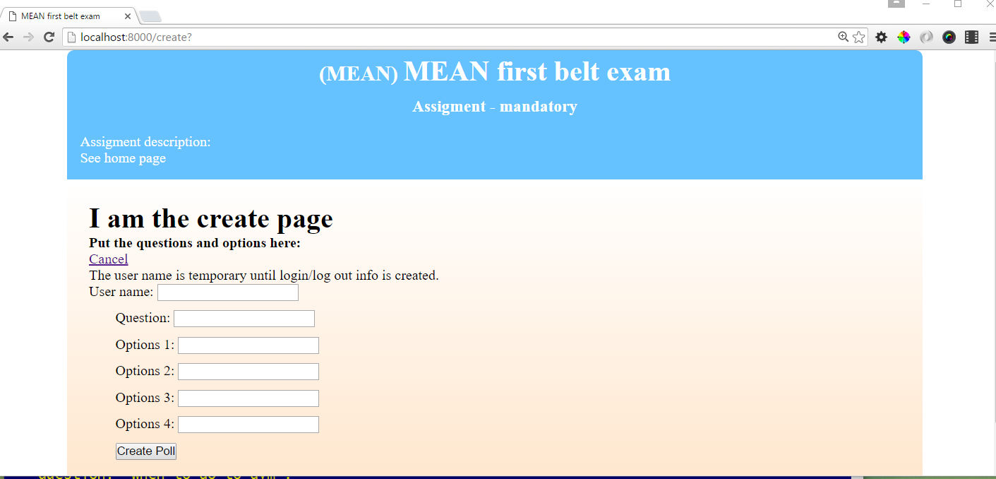

After entering a record you can see in the server console log that it added the record. It redirects to the home page.

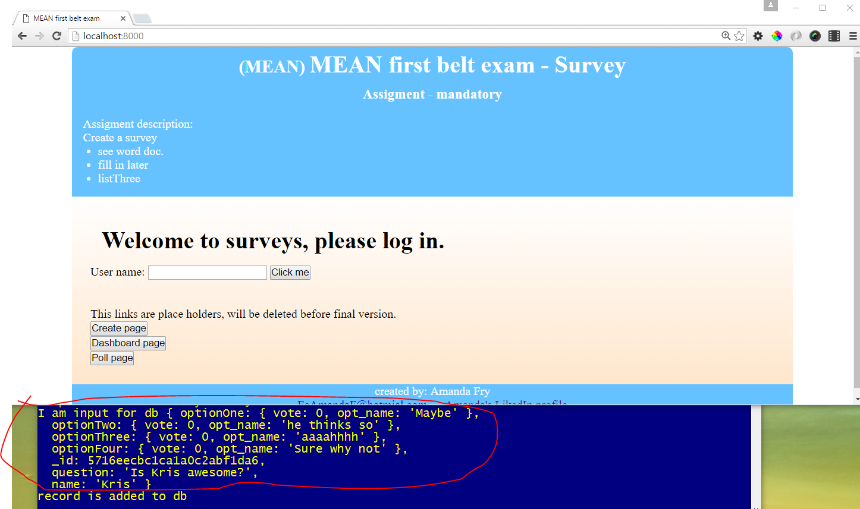

You can see the new record:

